**Practice to create and configure client-usernames, ACL profile and client-profile:**

* **Use in GUI:**
  + **Create a client-profile:**

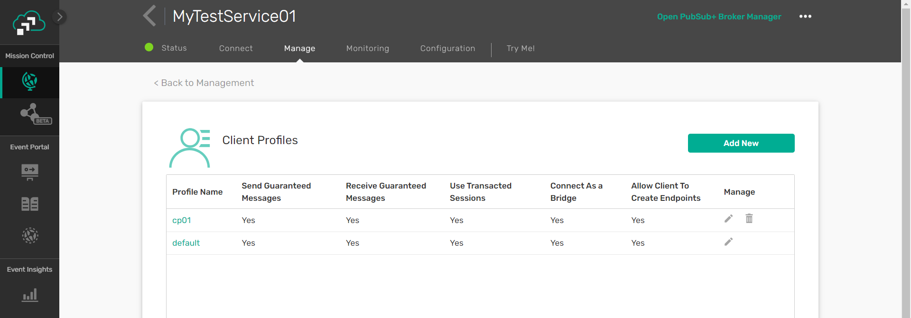

**Click on Add New.**

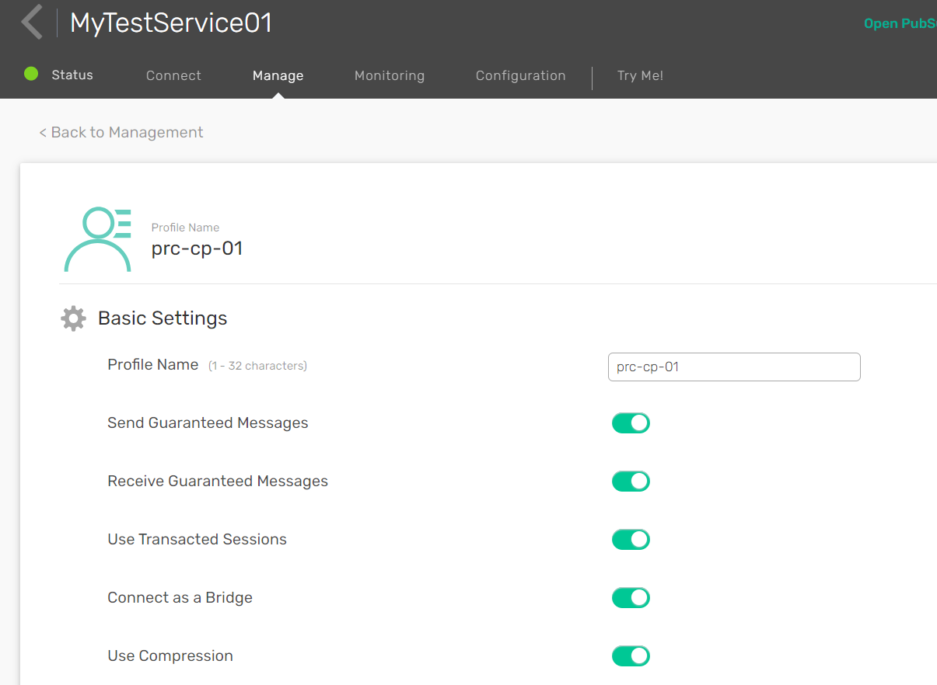

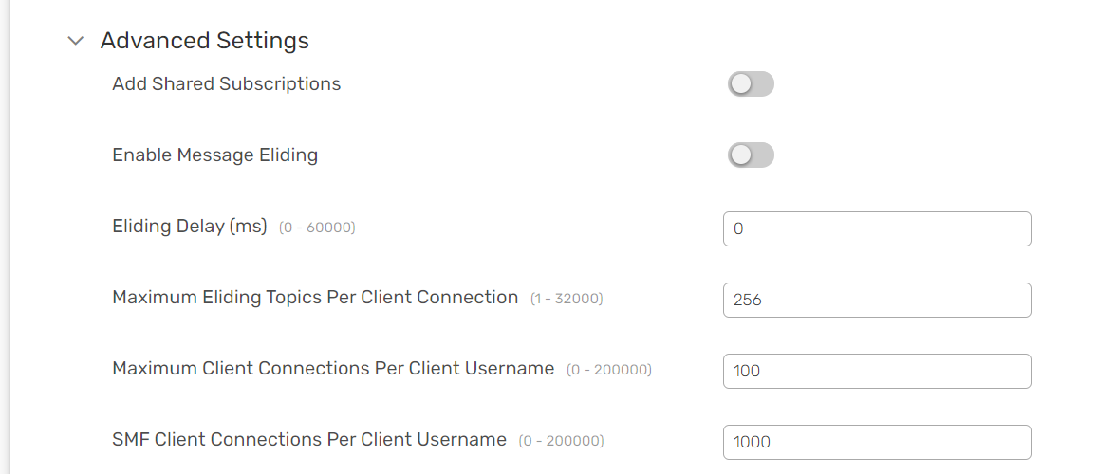

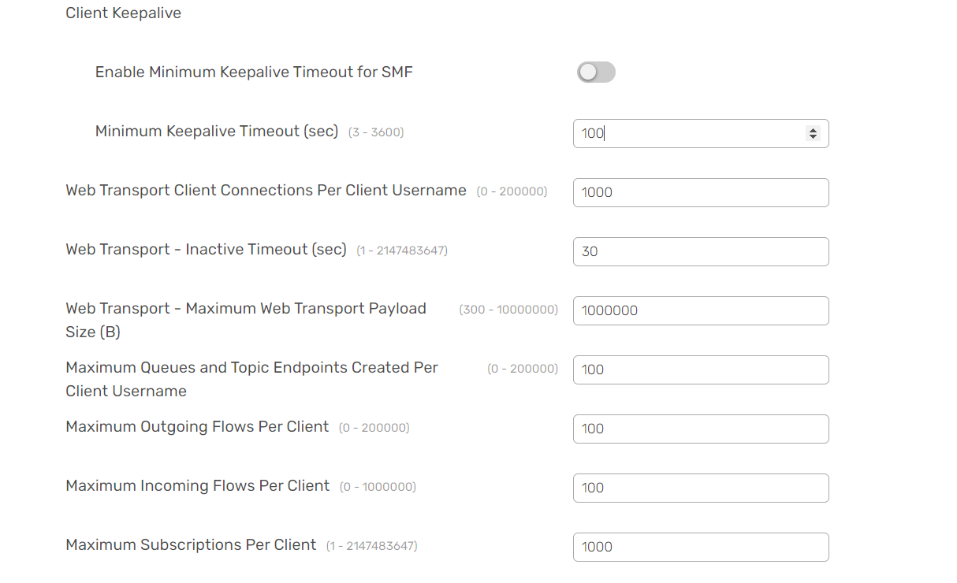

**Then, Save.**

**Check on it was created or not.**

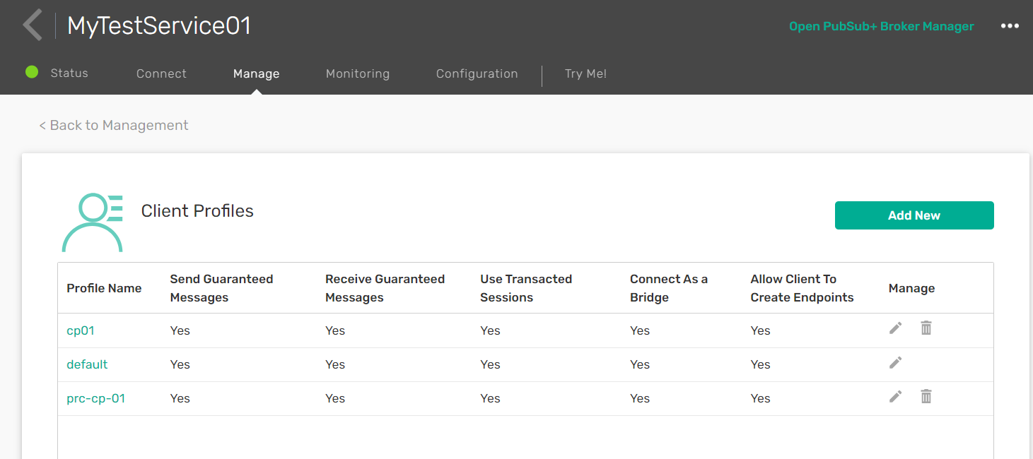

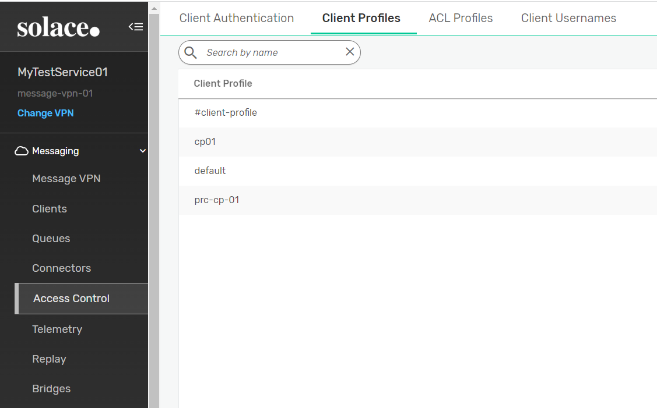

* **Now, create ACL-Profile:**

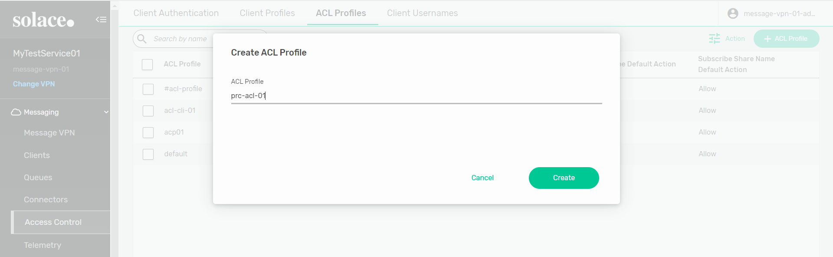

**Go to Client Connect --> edit --> allow**

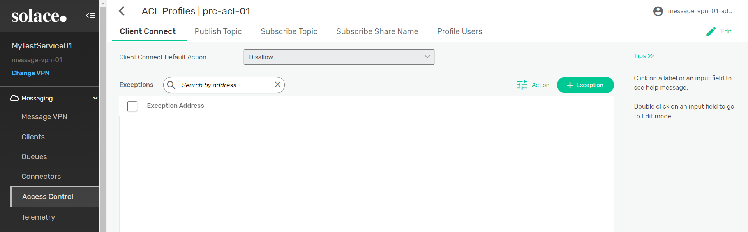

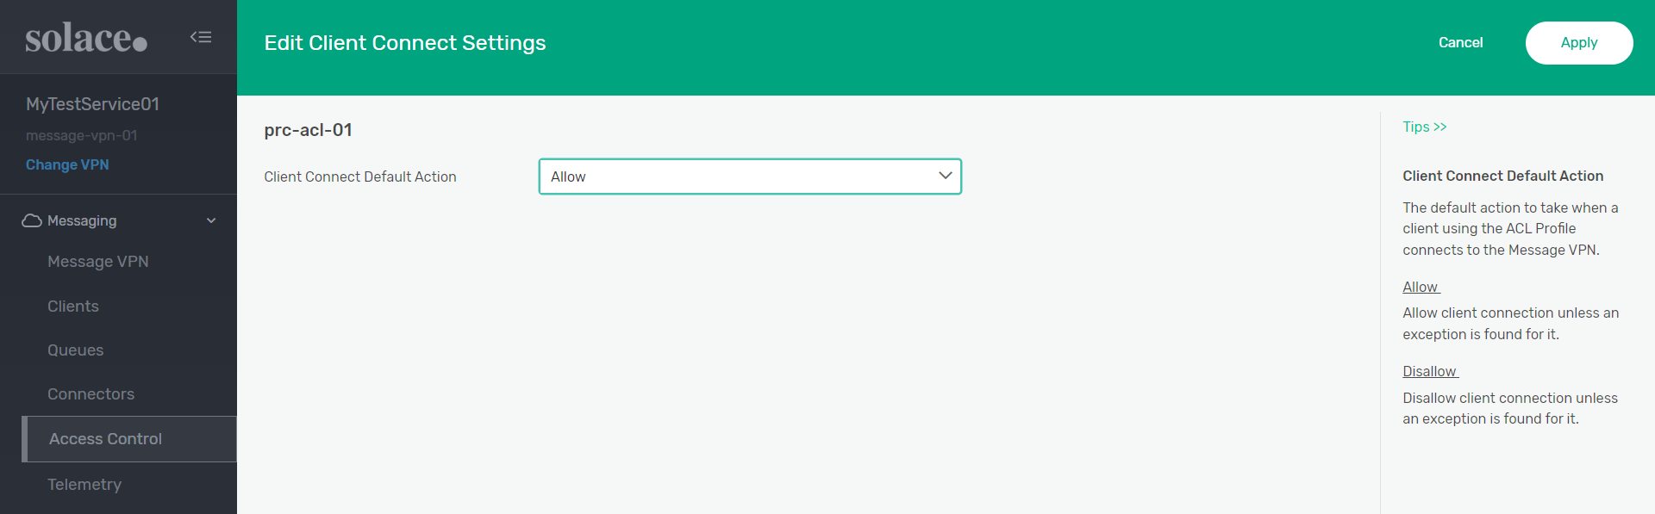

**Then, Apply.**

**Now, Go to Publish Topic --> edit --> allow --> apply.**

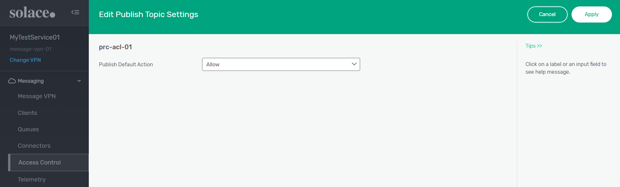

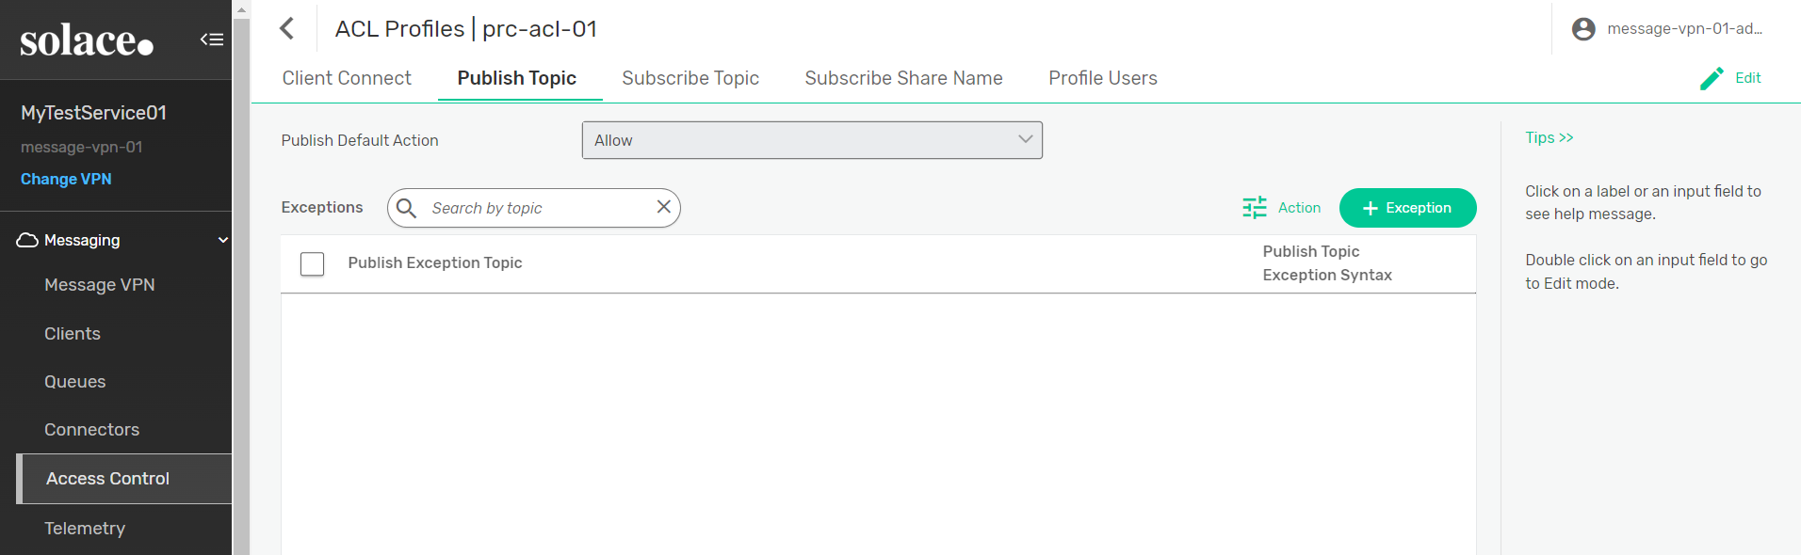

**Then, click on Exception.**

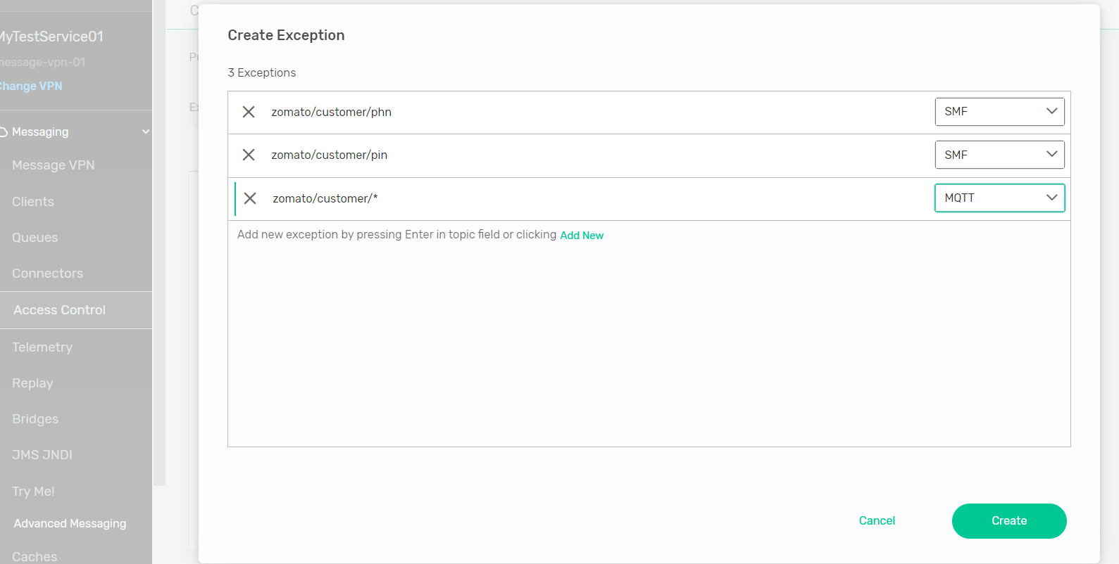

**Now, click on Create**

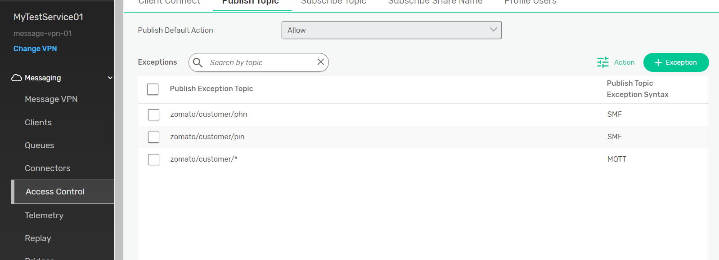

**Now, Go to Subscribe Topic --> edit --> allow --> apply.**

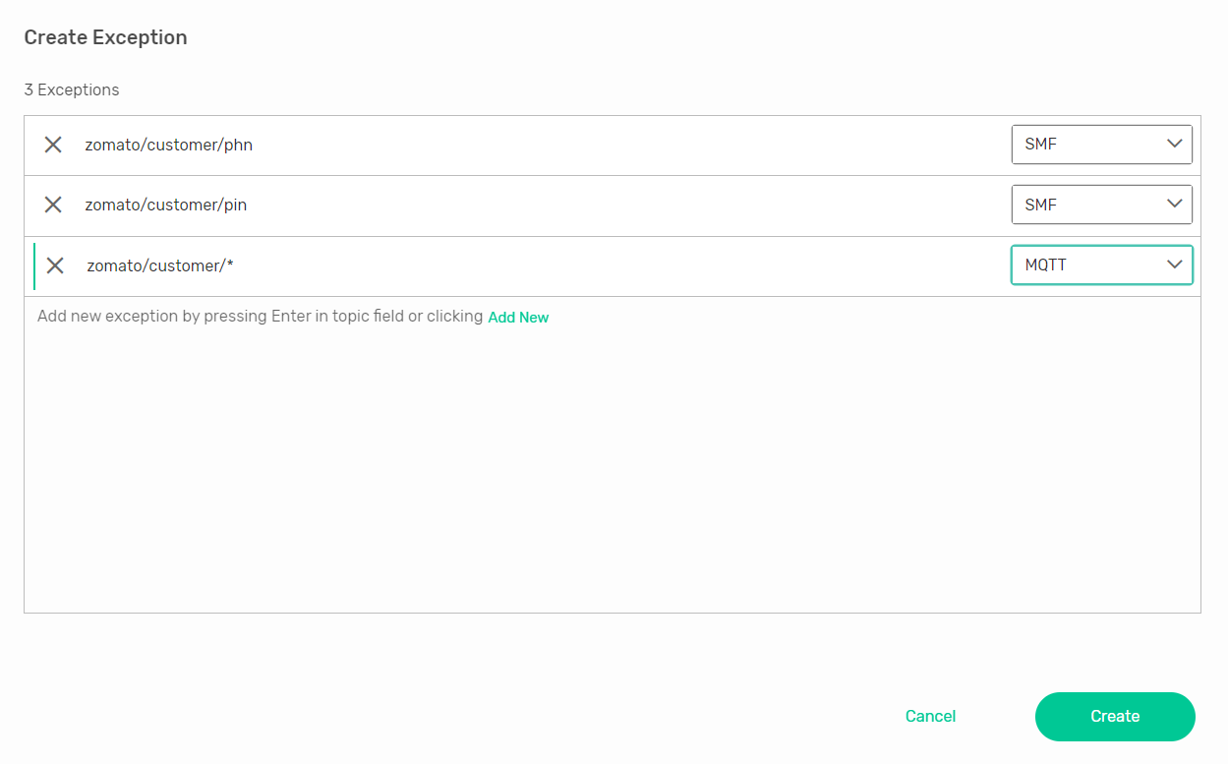

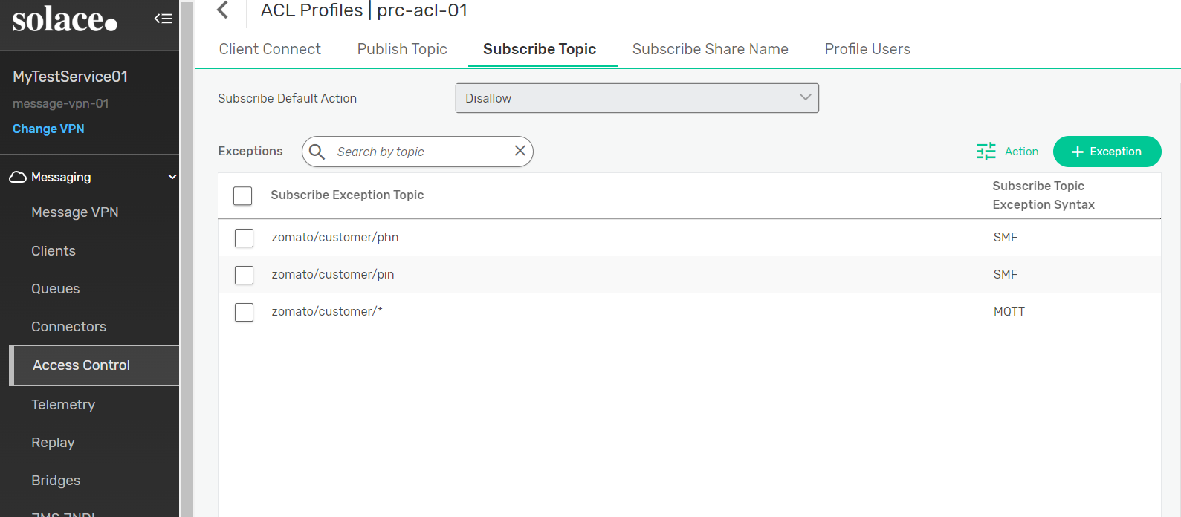

* **Create a client-username:**

**Go to client-username --> click on client-username**

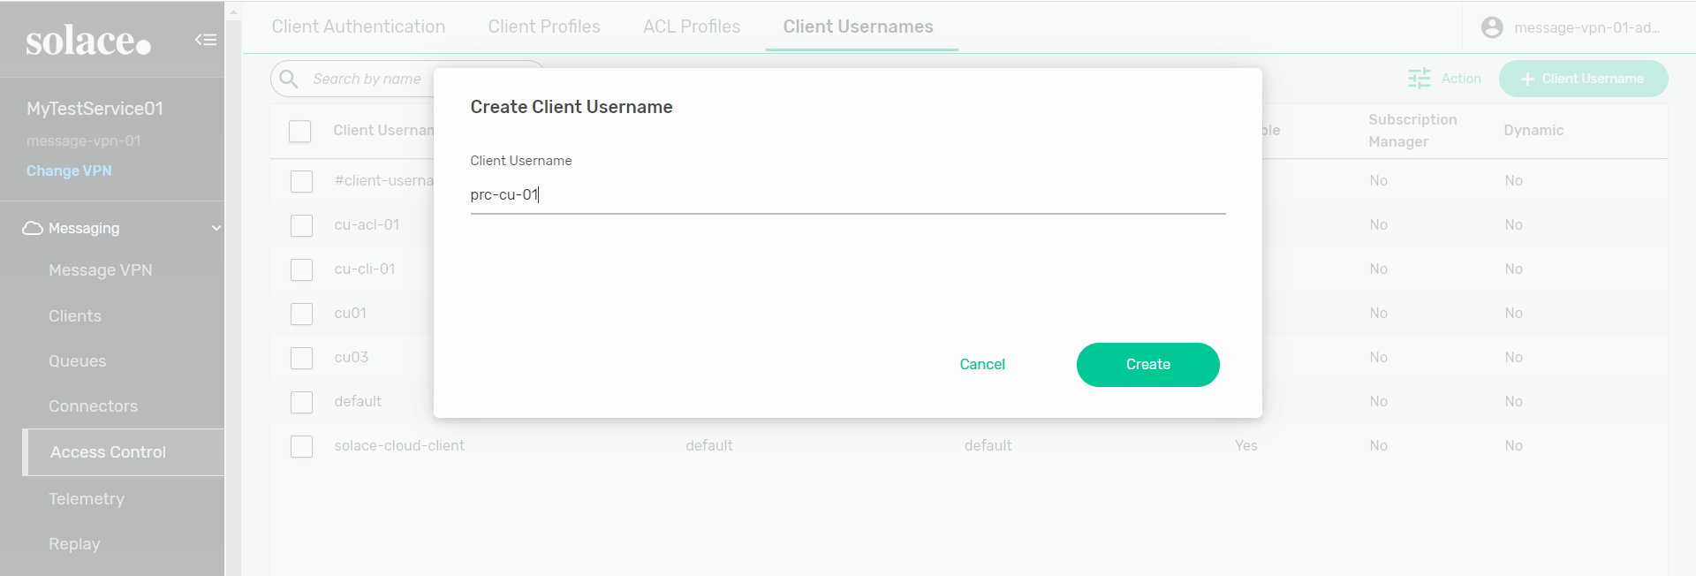

**Change some settings --> apply**

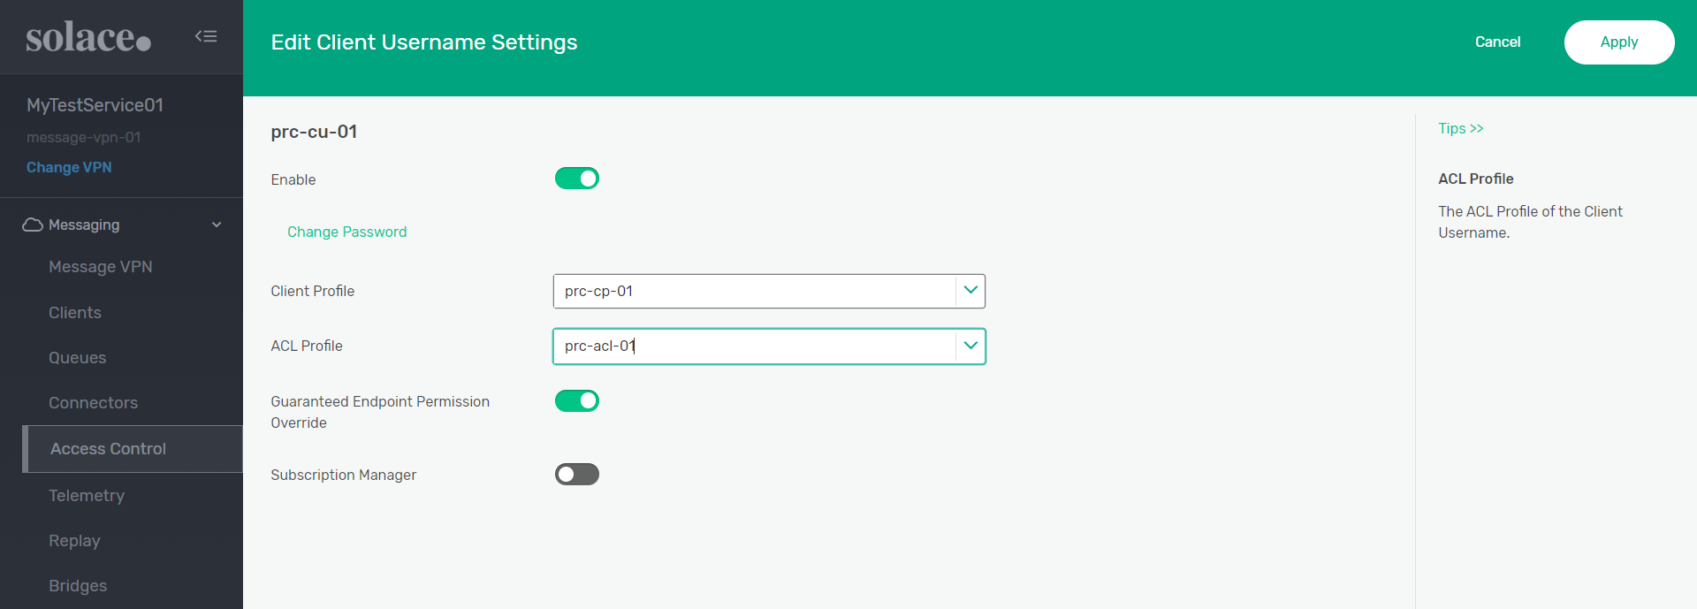

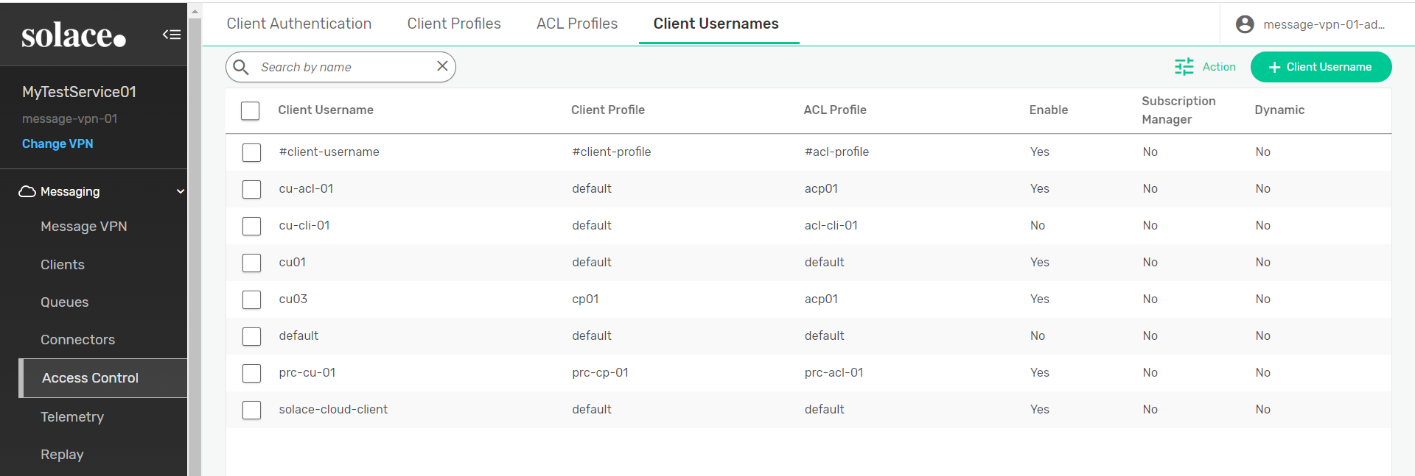

**Now, Go to the Queue.**

* **Create a new queue.**

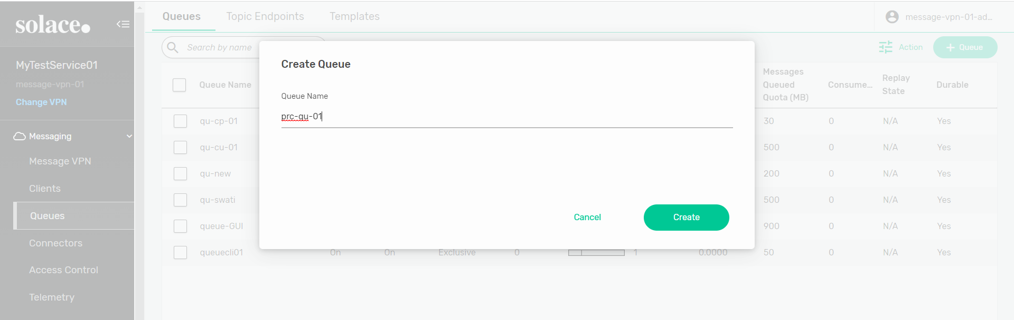

**Change some settings --> Apply**

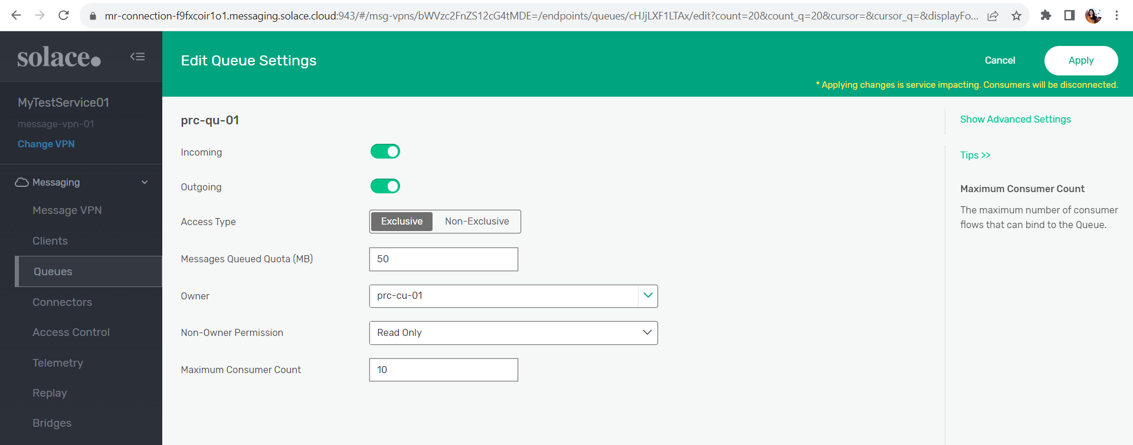

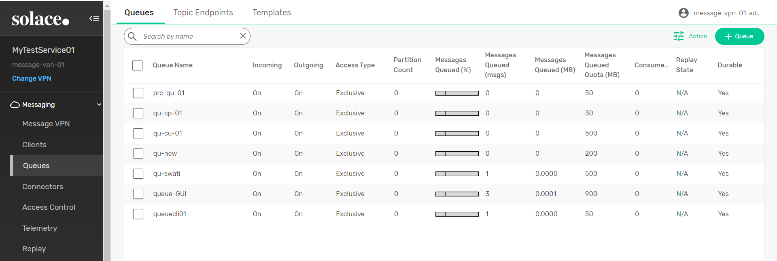

**Now, click on queue <prc-qu-01> --> go to subscription --> click on subscription --> create**

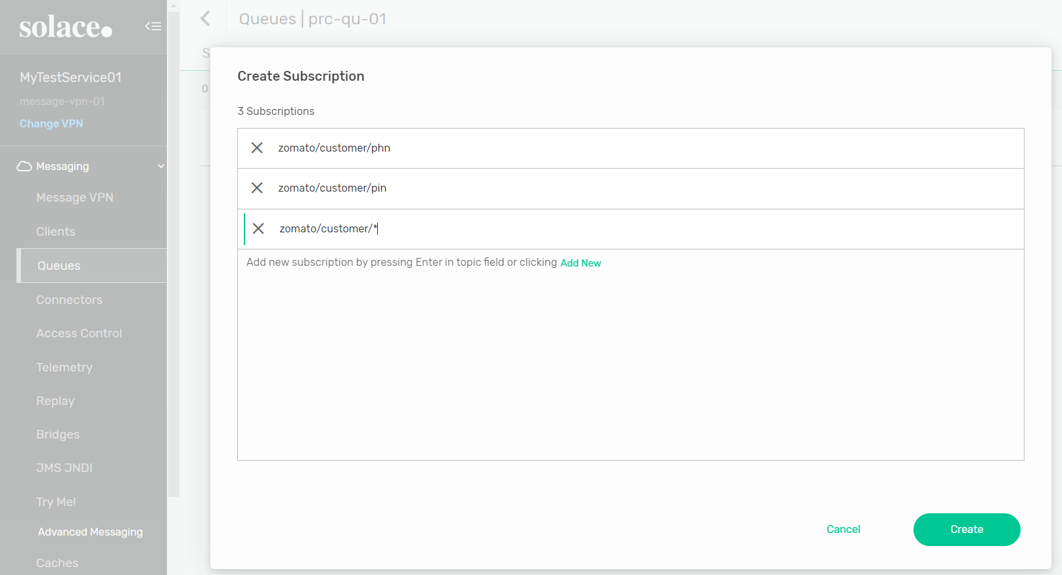

**Now, go to Try-me.**

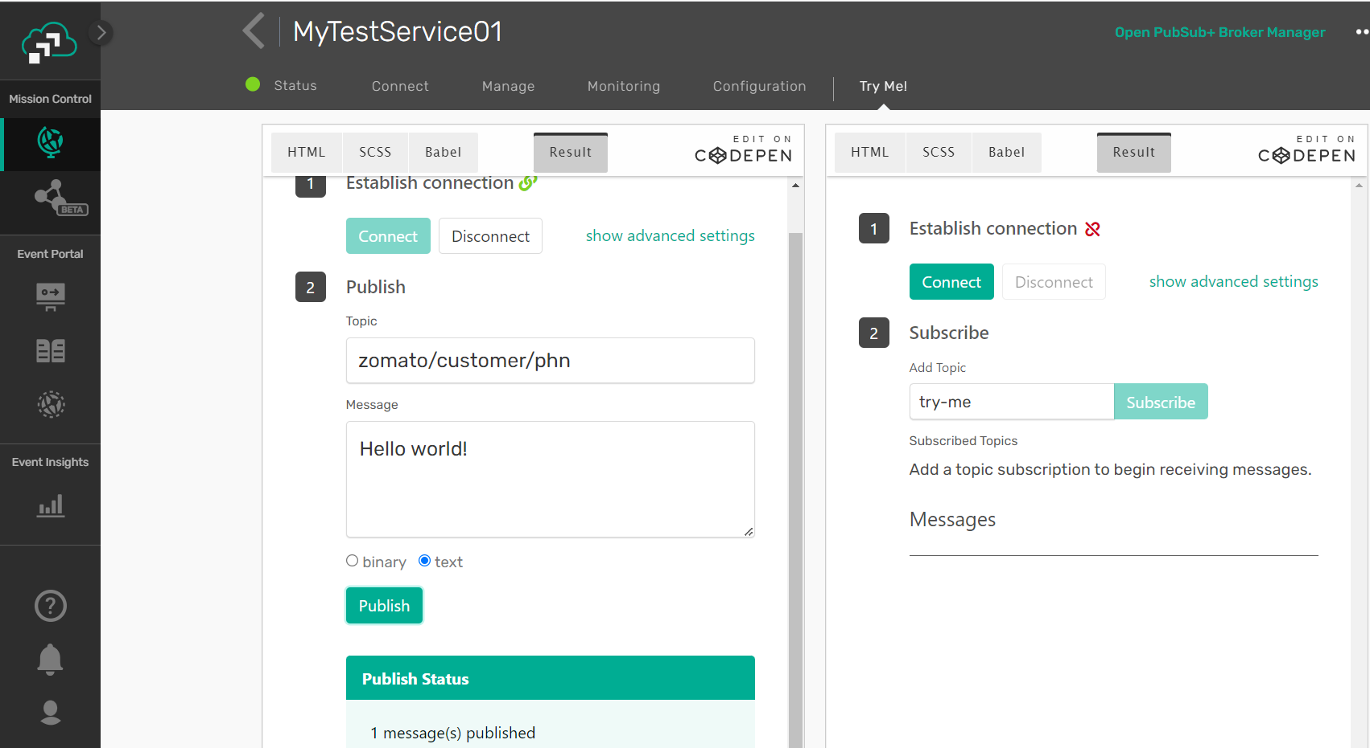

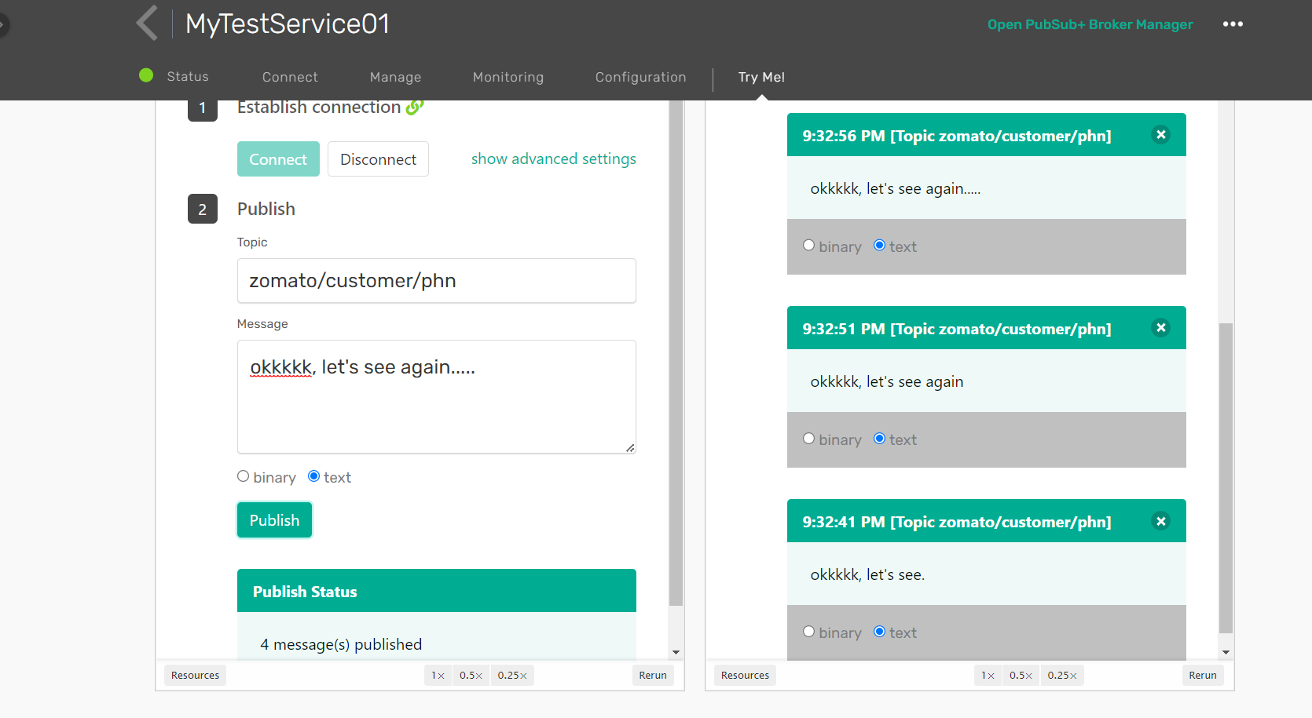

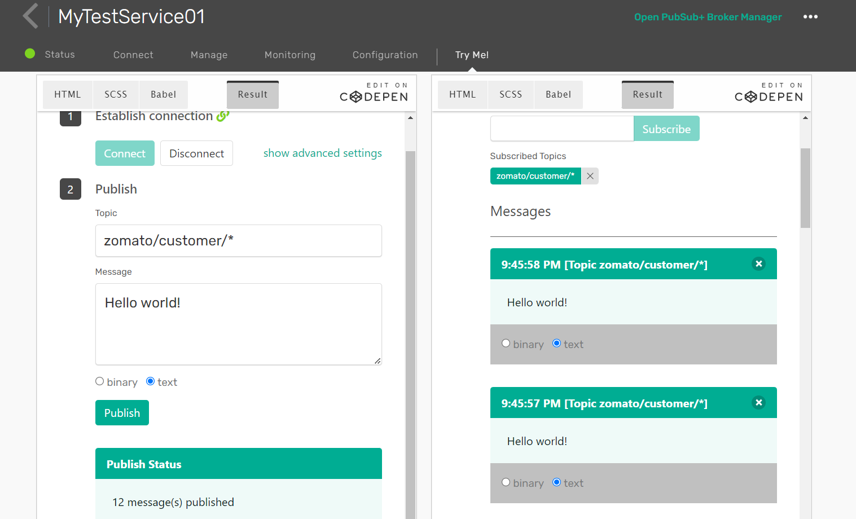

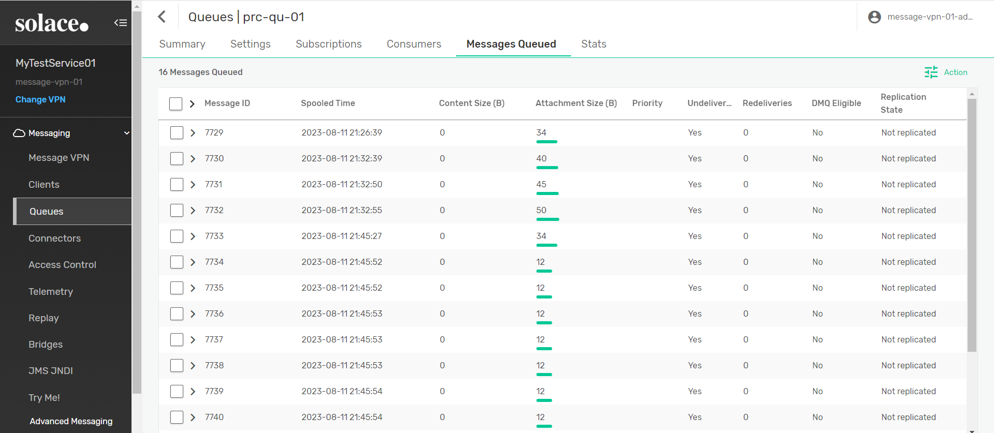

* **Use in CLI**
* **Create new Client-Profile <prc-cp-02> and Check using WEB GUI because it’s not work in CLI:**

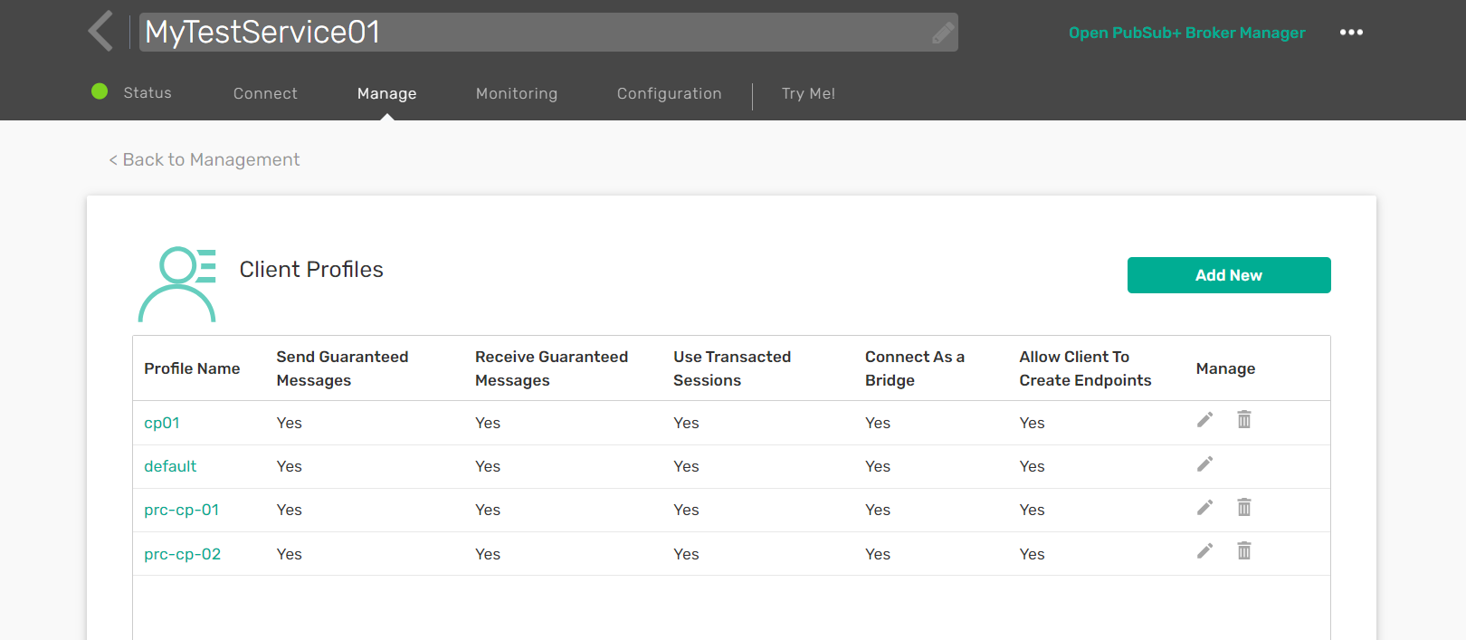

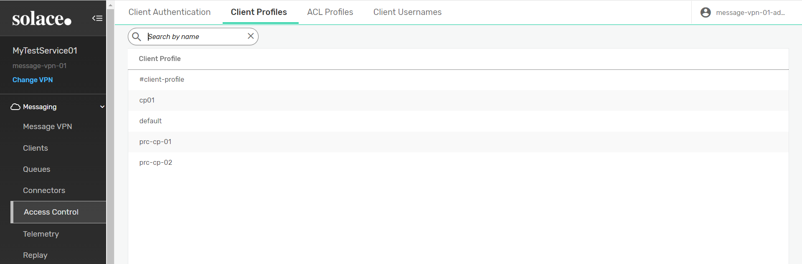

**Then go to putty:**

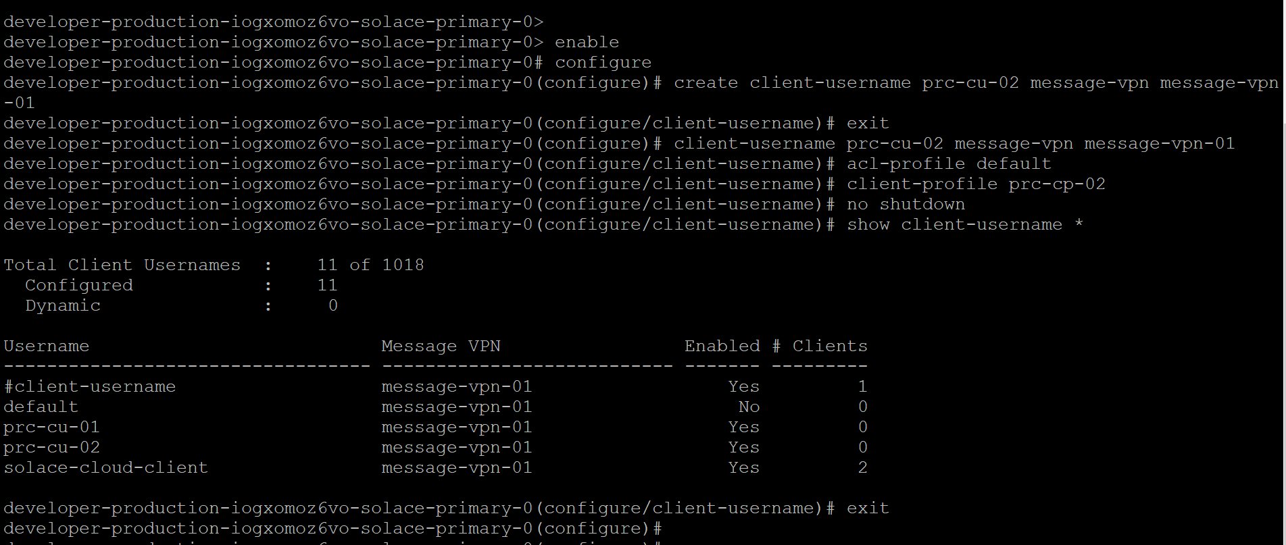

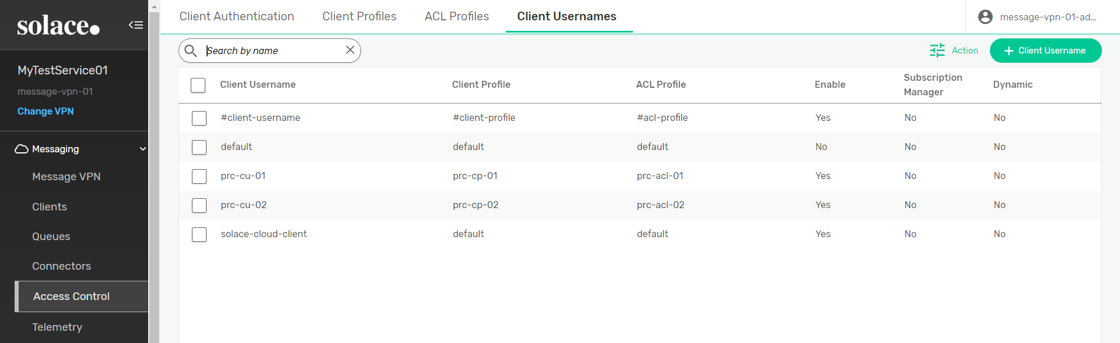

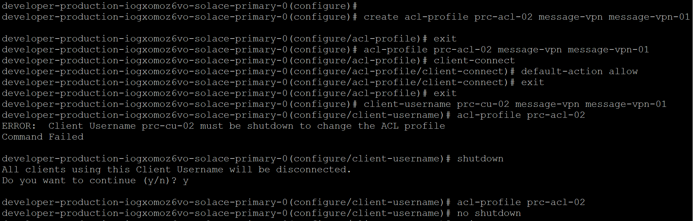

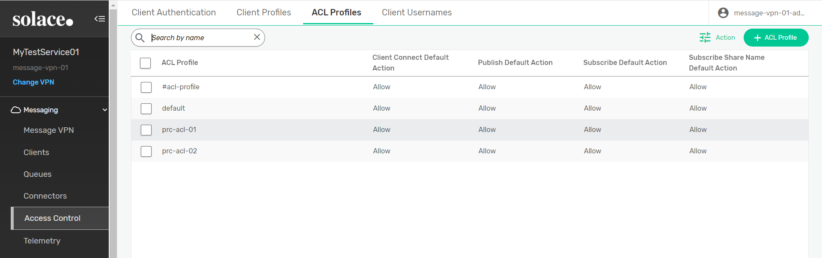

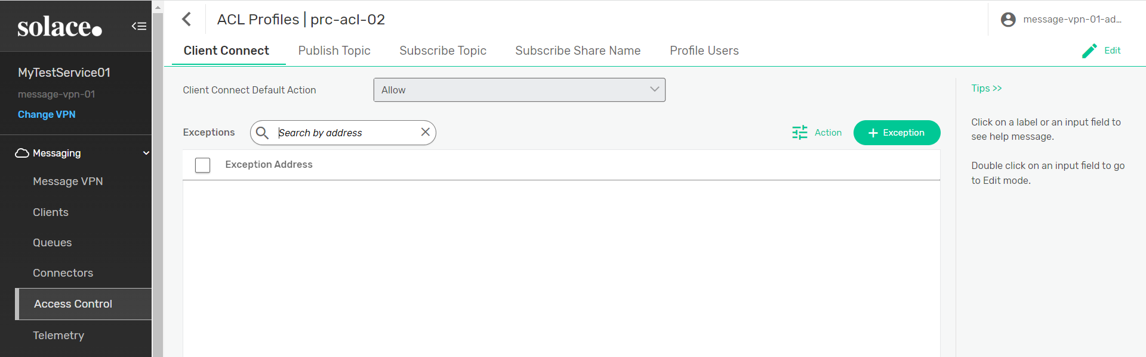

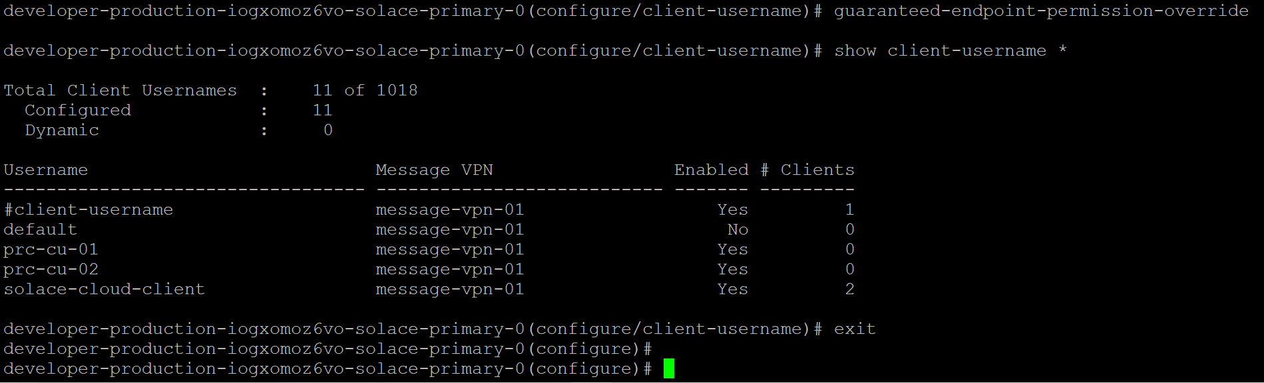

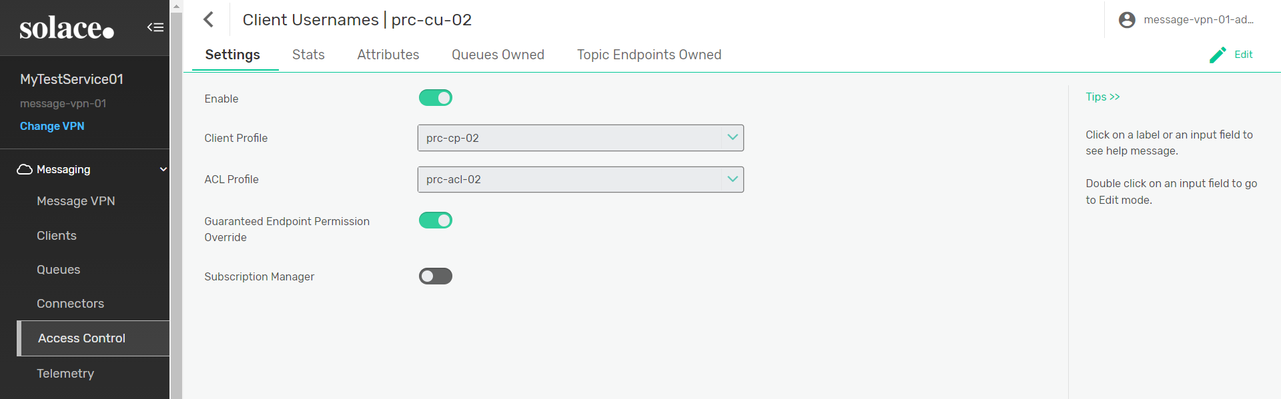

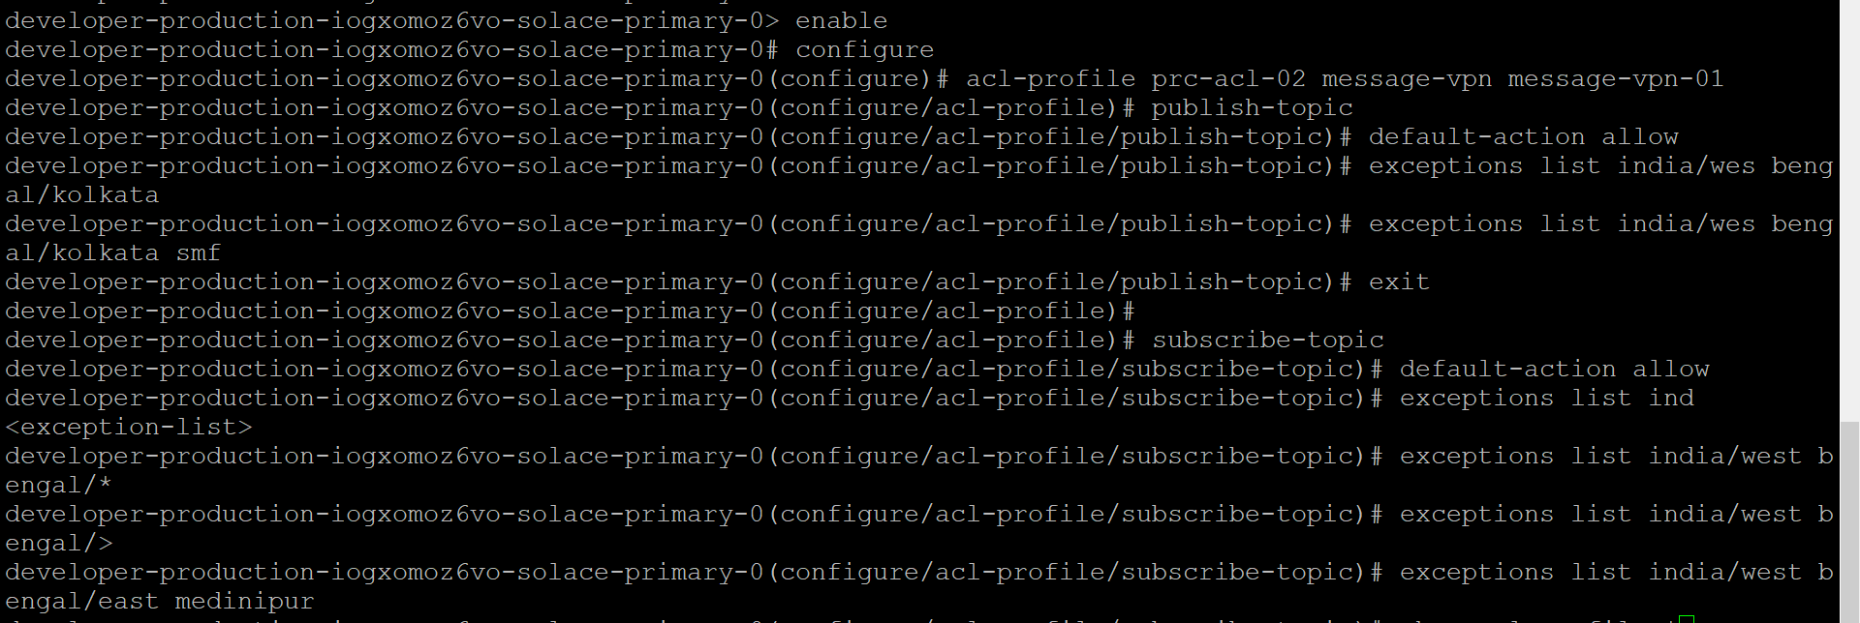

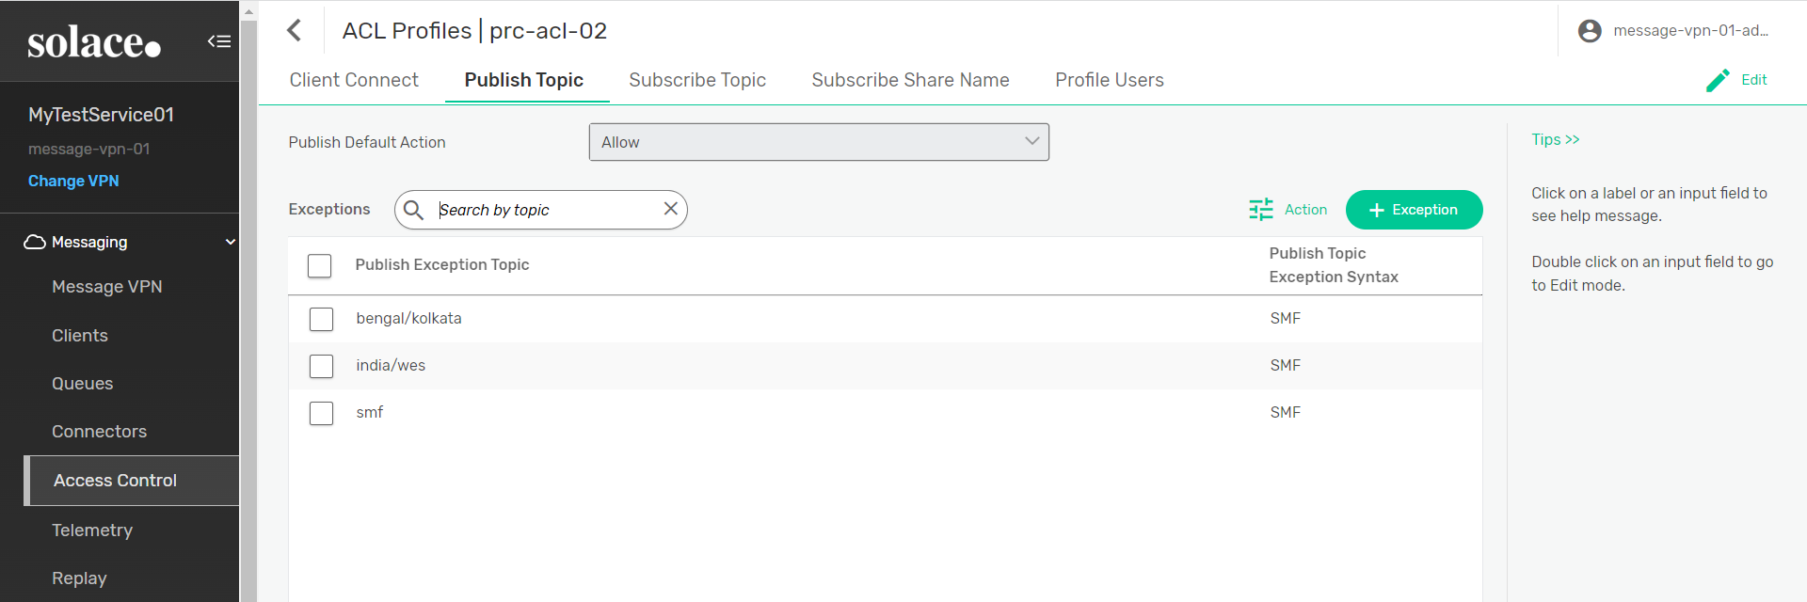

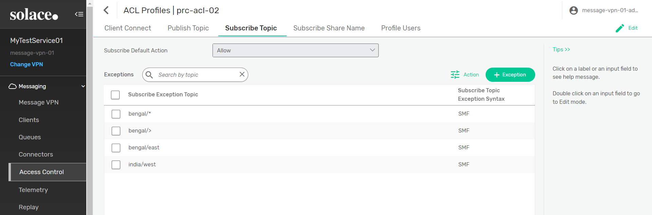

**How to delete a subscriber-topic exception list of ACL profile using Solace Command:**



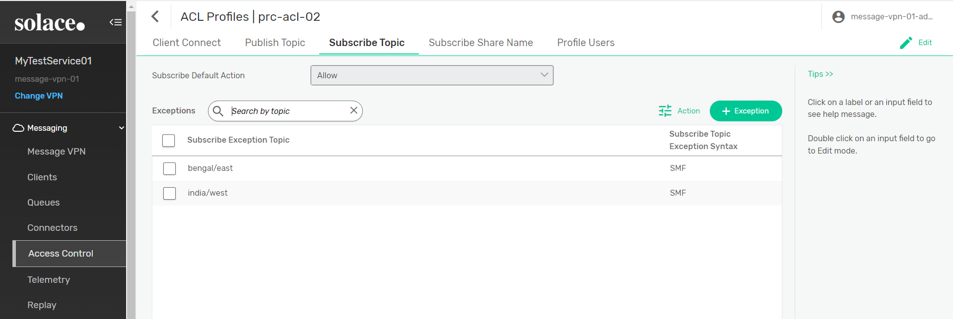

**Create a Queue with owner:**

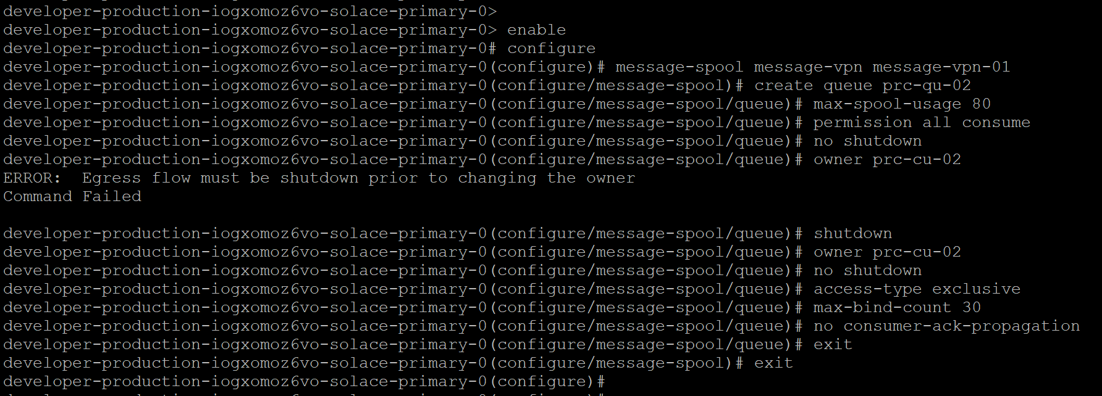

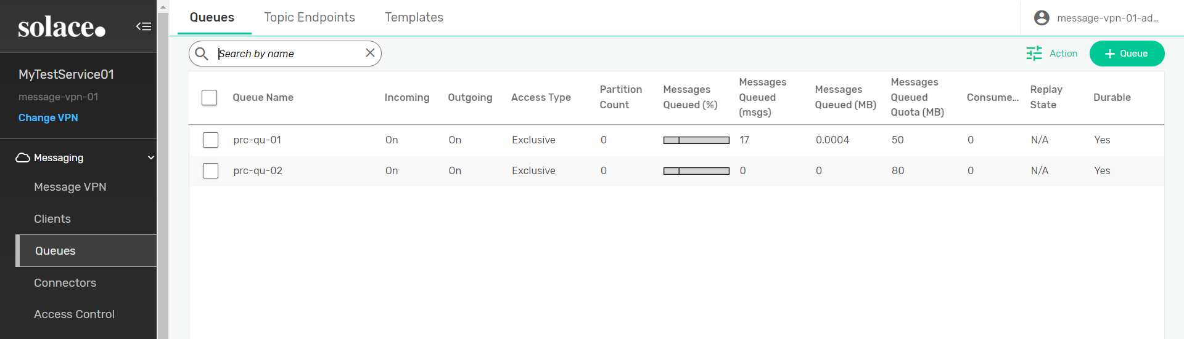

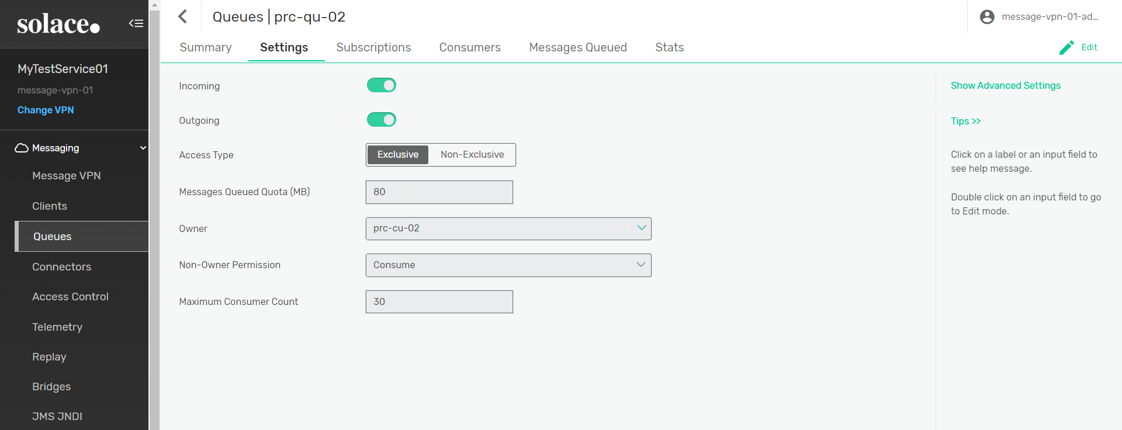

**Create Queue Template:**

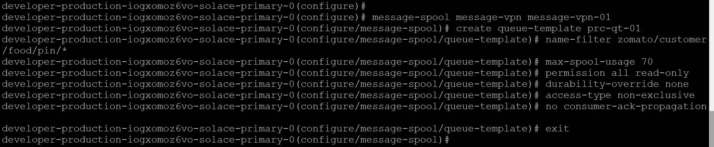

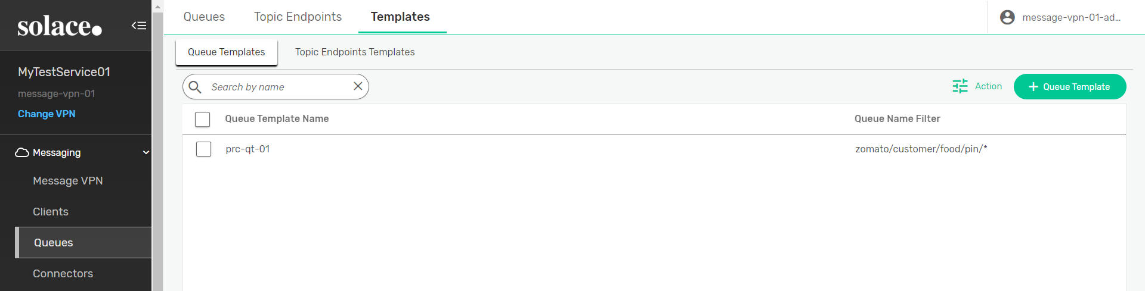

**Add Subscription Topic:**

